3.8 Maxima and Minima of Functions of Two Variables Worksheet

- True or False: Every function has at least one local maximum.

False. Consider the function . This function is a plane which has no local maximum or minimum.

- Suppose that is a differentiable function and . Determine if each of the following are True or False.
- If f has a local maximum or minimum at , then it always satisfies .

True. All local maximums and minimums happen at critical points and if then this means that is a critical point. So, there must be a local maximum or minimum at .

- If , then f has a local maximum or minimum at .

False. All local maximums and minimums happen at critical points, however not every critical point corresponds to a local maximum or minimum. Since we know that is a critical point, but we have no guarantee that there is a minimum or maximum here.

For example, consider the function which as a saddle point at the critical point of .

- If f has a local minimum at , then and .

False. We know that if we a local minimum occurs at if and , however it might also occur if the 2nd derivative test is inconclusive.

For example, has a local minimum at but .

- Find all critical points of the function .

We calculate that &

So, we need to solve the system .

The first equation will equal zero if or if .
The second equation will equal zero if or if .
Therefore, both equations will be satisfied at the points . In total this means that f has 5 total critical points.

- Find the critical points of and classify them as local maxima, local minima, or saddles points.

We calculate that .
We need . Therefore, we have a critical point at .

We calculate . Clearly these are all continuous functions.

We then calculate that . Since we know that the surface of has a local maximum at the point .

- Let be a function of two variables and suppose is a critical point of f. Furthermore, suppose:
Is a local minimum, local maximum, or neither?

Clearly are all continuous functions.

We then calculate that . Since we know that the surface of has a local minimum at the point .
- Find the local maximum and minimum values and saddle points of the function .

We calculate that .
We need .
We then see that if then . Also, if then .
Therefore, we have a critical points of .

We calculate . Clearly these are all continuous functions.
We then calculate that:
. Since we know that the surface of has a saddle point at .
. Since we know that the surface of has a local minimum at the point .

- Find the critical points of and classify them as local maxima, local minima, or saddles points.

We calculate that .
We need .
We then see that if then .
So and are critical points.
If then .
So is another critical point.

We calculate . Clearly these are all continuous functions.

We then calculate that:
. Since we know that the surface of has a saddle point at .
. Since we know that the surface of has a saddle point at .
. Since we know that the surface of has a local minimum at the point .
- Consider the following four regions in the plane.
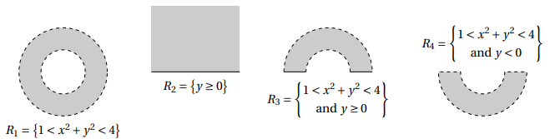

- Classify each region as either open, closed, or neither.
is open since it doesn’t include its boundary.
is closed since it does include its boundary.
is neither open nor closed since it only includes part of its boundary.
is open since it doesn’t include its boundary.

- Classify each region as either bounded or unbounded.
is bounded since it doesn’t extend forever in any direction.
is unbounded since it extends infinitely in the horizontally and in the positive vertical direction.
is bounded since it doesn’t extend forever in any direction.
is bounded since it doesn’t extend forever in any direction.

- Let be a differentiable function on the disk in , where
- for every point on the circle .
- f has only one critical point, which is at .
Decide which of the four statements below is true.

- The relationship between cannot be determined from the given information.

The statement B is correct.
We know that since we are working on a closed and bounded region D the function f will obtain an absolute maximum and minimum value on D by the Extreme Value Theorem. By the first two bullet points we know that f does not achieve its absolute minimum on the boundary since for any on the boundary of D we are told that and . This then means that f must obtain its absolute minimum at a critical point. Since the only critical point is at the minimum must be obtained here which implies that .
- Find the absolute maximum and minimum values of on the rectangle given by .

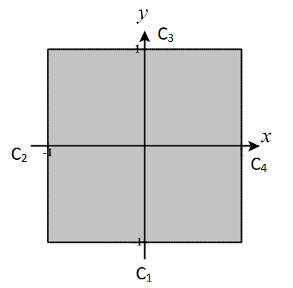
First, we will draw a picture of the set D. We easily see that D is closed and bounded. So, by the EVT we know that an absolute min and max occur on D.
We calculate that and .
To find the critical points we need to solve the system: .
The first equation implies that .
If then by the second equation .
If then by the second equation .
Therefore, we have three critical points: . However, is the only critical point in D and is therefore the only critical point we must consider. We see that .

Now we must check for extremes along the boundary of D.

Along the segment the function becomes where . We know that this is a parabola that opens upward with vertex occurring at . Therefore, the extreme values along are and .

Along the segment the function becomes where . We know that this is a parabola that opens upward with vertex occurring at . Therefore, the extreme values along are and .

Along the segment the function becomes where . We know that this is a parabola that opens downward with vertex occurring at. Therefore, the extreme values along are and .

Along the segment the function becomes where . We We know that this is a parabola that opens upward with vertex occurring at . Therefore, the extreme values along are and .
We see that the absolute maximum value of on D is 11 (occurring at and ) and the absolute minimum value of f on D is 4 (occurring at )
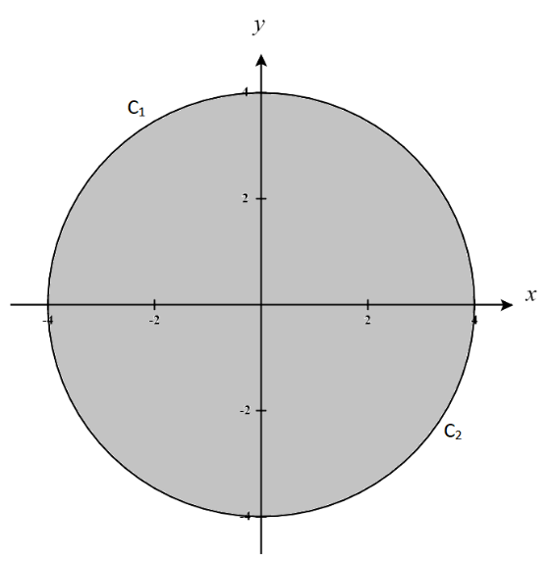
- Find the absolute maximum and minimum values of on region .

First, we will draw a picture of the set D. We easily see that D is closed and bounded. So, by the EVT we know that an absolute min and max occur on D.
We calculate that and .
To find the critical points we need to solve the system: .
The first equation implies that and the second implies that
Therefore, we have a single critical point of . We see that .

Now we must check for extremes along the boundary of D.

Along the segment (the left half of the circle) the function becomes where . We know that this is a parabola that opens downward with vertex occurring at . Therefore, the extreme values along are and .

Along the segment (the right half of the circle) the function becomes where . We know that this is a parabola that opens downward with vertex occurring at . Therefore, the extreme values along are and .

We see that the absolute maximum value of on D is 35 (occurring at ) and the absolute minimum value of f on D is -48 (occurring at )

- Consider again the function on region as in #11.
- Why would it be inconvenient to divide the boundary of D into two curves with formulas ?

If we use this division of the boundary then when we observe what the function becomes along each curve we will obtain .
While there is nothing wrong with this we can see that this function will more difficult to maximize and minimize.

- What would the function need to look like so that dividing the boundary of D into two curves with formulas would be convenient to use?

There are many answers to this question. Below are a few options:

(This will make )
(This will make )
Note that both of these options allow the resulting function to not contain any square roots.

- Find the absolute maximum and minimum values of on the triangle with vertices .
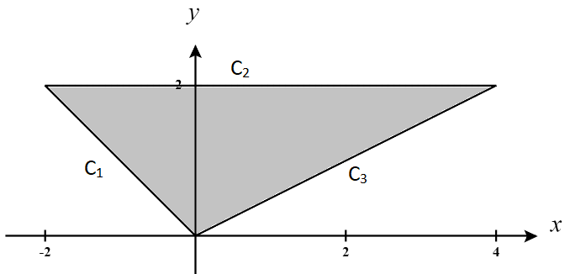
First, we will draw a picture of the set D. We easily see that D is closed and bounded. So, by the EVT we know that an absolute min and max occur on D.
We calculate that and .
To find the critical points we need to solve the system: .
The second equation implies that .
If then by the first equation . If then by the first equation.
Therefore, we have only one critical point of . We see that
Now we must check for extremes along the boundary of D.

Along the segment (given by the equation ) the function becomes where . We can easily see that the extreme values along are and .

Along the segment (given by the equation ) the function becomes where . Finding the extremes along will be more difficult to do than in previous examples since we have a more complicated function. We will use our knowledge from Calculus I to find absolute minimums and maximums of this curve. We see that:
This function has critical values of . Therefore, is the only critical value in . When checking the outputs when compared with the endpoints we have: .
So along the extremes are

Along the segment (given by the equation the function becomes where . Very clearly along the function f is always 0. Therefore, the extreme value along is for all .

We see that the absolute maximum value of on D is 24 (occurring at ) and the absolute minimum value of f on D is (occurring at ).

